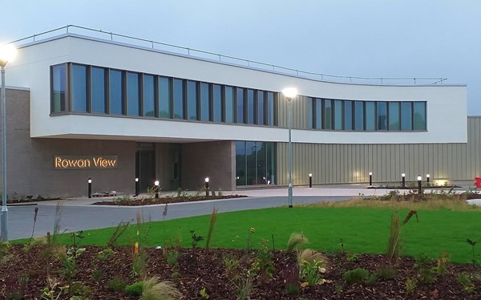
ROWAN VIEW HOSPITAL

In 2020 Mersey Care opened a high quality regional medium secure unit on our Maghull Health Park. This £53 million development is called Rowan View and represents our strong ambition for a new centre of excellence in forensic care. It is a place of innovation, using the latest technology and therapeutic techniques and specialist staff including experts in mental ill health and learning disability care across a wide range of disciplines including occupational therapists, psychologists, support staff and nurses.

The Rowan View Journey!
https://www.youtube.com/watch?v=5GEb2PleLR0

Rowan View has 123 beds over eight wards:
- Female Learning Disability (Delamere Ward)
- Male Learning Disability (Astley and Birkdale Wards)
- Female Mental Illness (Eden)
- Male Mental Illness (Thornton, Rivington, Vale and Marbury Wards)

At Rowan View, the patients have access to an environment that will promote the integration of physical and mental wellbeing, this includes the following:
- A social hub incorporating a café, therapy rooms, multi faith room, sports hall, gymnasium, music rooms, skills for life room, IT suite, bank and a physical health suite
- Use of therapeutic technology for the benefit of patients including virtual reality and avatar therapy
- Art and design created by expert designers working closely with service users to enhance the site, its reception and corridors and its therapeutic spaces
- Flower gardens and green spaces

Have a look at the 360 tour of Rowan View Hospital using the link below!
https://my.matterport.com/show/?m=ND4STJ2Fxkn/
https://my.matterport.com/show/?m=BGdUogDZisL/
https://my.matterport.com/show/?m=7YF53p3R2Ac/
https://my.matterport.com/show/?m=kdrjW9AHdif/
https://my.matterport.com/show/?m=3SaAMYDvNBn/

Your thoughts!
Why do you think it is important that we create an environment as detailed above and shown in the tour for our patients? List three reasons
1
2
3

Why do you think it is important that we create an environment as detailed above and shown in the tour for our staff? List three reasons
1
2
3

Rowan View represents a step change in care for service users, preparing them for life afterwards. It will deliver innovative treatments to improve recovery times for people with mental health and learning disabilities’.

Why do you think the new facilities at Rowan View will improve recovery time for people with mental health & learning disabilities?

