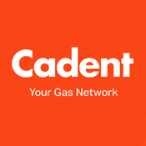

Name |  | Form

Task Five – CISBOT!
You many have met CISBOT on our 360 Virtual Tour – in case you didn’t, here I am! https://youtu.be/CBgPSgutfvI
You will also need to use the following link for this task https://cadentgas.com/about-us/innovation/cisbot
How does CISBOT work?
List three reasons that makes CISBOT revolutionary.
1
2
3

Where did the case studies take place?
1
2
3

The government has set a target to have net zero carbon emissions by what date?

Why is this? – You can use the Chatbot to help you.

What is Hydrogen?

What is Biomethane?

Find the timeline – when did we start using fossil gas?

Any thoughts on why this move to zero carbon emissions is important?

Thank you for completing this task on Cadent Gas

Copyright Elevate EBP

