Name |  | Form

Task Four
Values & Culture - Do your research!
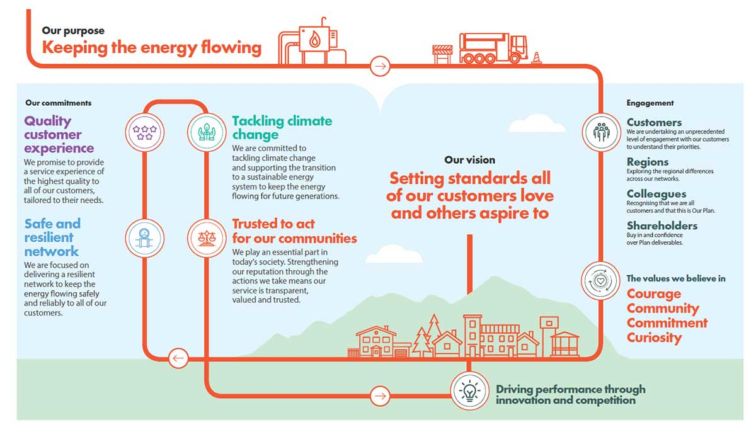
www.cadentgas.com

What does Diversity & Inclusion mean?
Why is this important in any organisation?
What is Cadents Vision?
What is Cadents Purpose?
List the four C’s that are important to Cadent (the first one is done for you!)
1 Curiosity
2
3
4
List their four approaches and write a brief statement why these are important
1
2
3
4
What percentage of Cadents workforce is:

- Female
- Identified themselves as BAME
- Identified as having a disability.
- Identified themselves as LGBT

Why is this important to them?

Why is this important to you?

Thank you for completing this task on Cadent Gas

Copyright Elevate EBP

