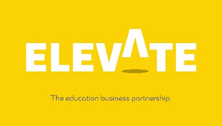

Name |  | Form

Task Four

Health & Wellbeing Planning Event

https://youtu.be/c8WNmPpqOMA

At ‘The Sovini Group’ we take pride in looking after our staff and their health & wellbeing is important to us. Throughout the year we have to book in a minimum of 15 activities for the staff to take part in. The activities have to boost staff moral and motivation and action certain topics. Below we have given you some ideas around potential activities.

Your task is to create your own 12 months plan of activities for our staff in your own unique way! Time to get creative

Some key pointers: examples

Month | Ideas/pointers | Example | Reason for initiative
January | New Year New Me/ Difficult month | Free virtual PT session per week | A lot of people like to start a health journey in the New Year and this would support
February | Valentines
March | Busiest month of the years as final month of financial year
April | Easter
May
June | Summer starts
July
August | People start saving for Christmas
September
October | Flu season starts
November | Bonfire
December | Christmas

Thank you for completing this task on The Sovini Group

Copyright Elevate EBP

