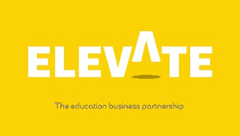
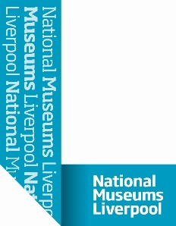
Name |  | Form

Welcome to your Virtual Work Experience at National Museums Liverpool (NML)!
Task One
Have a look around the museum! https://my.matterport.com/show/?m=WRkf3EYPBnG/
Introduction to National Museums Liverpool (NML) Web address link https://www.liverpoolmuseums.org.uk/
It all started way back in 1851 when the 13th Earl of Derby donated his enormous natural history collection to the town of Liverpool. This was the beginnings of what would one day become World Museum.
Fast forward over 160 years and the creation of 6 more museums and galleries, Liverpool now has one of the largest collections of museums and galleries in the UK.
In 1986 it was decided that the museums in the city had collected works of art and objects of such historic and scientific significance that ownership should be handed over to the nation in order to protect them. From here, National Museums Liverpool was born.
We exist today to allow you, and future generations, to learn from and enjoy our amazing, varied collections and venues.

Task one
 | Research Task | Notes/Responses
1a. | Click on the link below  https://www.liverpoolmuseums.org.uk/about  - What is NML’s mission?  - What are NML’s Values?
1b. | - How do they make you feel? What do you expect from the museums based on this information?
2a | - How many museums make up National Museums Liverpool?
2b | - Pick one of the museums and find out three interesting pieces of information about it. What made you pick that venue? Did you learn anything new about it?

3 | - List all the types of jobs that you think might be available at NML.
4 | - Now follow this link to NML’s leadership team https://www.liverpoolmuseums.org.uk/about/senior-staff  - Can you add any more job roles to your list?
5. | - List three jobs from your list that sound interesting to you.  - Why did you pick those roles?

Thank you for completing this task on National Museums Liverpool

Copyright Elevate EBP

