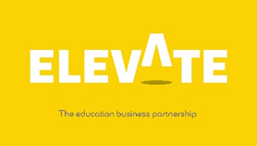
Virtual Work Experience

Name |  | Form

Welcome to your Virtual Work Experience at The Sovini Group!
As part of your Work Experience, we want you to find out about us as an employer. We hope that what you learn will help explain why we are all so proud to be a part of this amazing organisation and may encourage you to want to be part of it to!
https://my.matterport.com/show/?m=XLhnFiigomE/
Visit the following webpage www.sovini.co.uk
Have a look around the website and then answer the following questions:
1 | When did the Sovini Group Journey begin?
2 | List our five company ‘Values’  1  2  3  4  5
4 | Name our three ‘Shared Central Services’  1  2  3
6 | Careers - Sovini Group : Sovini Group  Sovini has won awards for being the ‘best place to work’. Using the link above, under ‘The Way We Work’. List your top three reasons why you want to work for us (pick 3 from the bullet points)  1  2  3
6 | Name three types of jobs you will find at the Sovini Property Group  1  2  3
7 | Find our list of ‘Certifications’ that we have. What is the most important to you and why?

Thank you for completing this task on The Sovini Group

Copyright Elevate EBP

