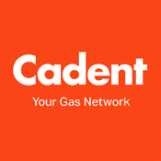

Name |  | Form

Task Three
Employ Me!
Use this task to sell yourself as a candidate to work at Cadent Gas. Don’t worry about the role just think about the qualities that the company look for in the people they employ.
https://youtu.be/8HQrsmX36iE
Write a minimum of 200 words!
Name:

Thank you for completing this task on Cadent Gas

Copyright Elevate EBP

