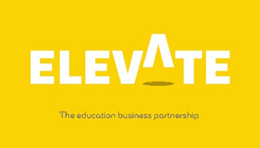
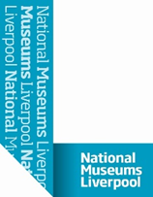

Name |  | Form

Task Three
You should have now spent some time looking through the 360 tour and listening to the team talk about their jobs!
List 5 things that you have found out about National Museums Liverpool that you didn’t know before

1
2
3
4
5

List five different careers/jobs that exist within National Museum Liverpool that are connected to the gallery tour you have watched
1
2
3
4
5

What job is most suited to your personality?
Please explain why this is?
What qualifications do you need for this role?
Could you gain some work experience/voluntary work outside of the museum around the role you are interested in to develop the skills & qualities needed for the role and if so where?
Please use the link below to discover free online learning!

https://learndigital.withgoogle.com/digitalgarage

Thank you for completing this task on The National Museums Liverpool

Copyright Elevate EBP

