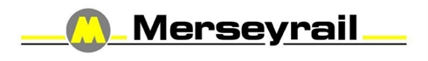
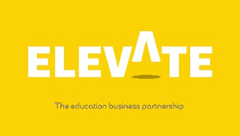

Name |  | Form

Task Two
https://my.matterport.com/show/?m=ph3q16bkcp1/
https://youtu.be/yf-4h5m8BWU
FUNCTION – SAFETY & SECURITY
Safety and security are core values in how Merseyrail operate. We take personal and collective responsibility to create a safe and secure environment that minimises the risk of harm to our employees, our passengers, service partners and all others affected by our activities.
We have safety and security management systems that enable us to meet our legal duties, but it is our culture that brings those systems to life and every employee and service partner has a role to play in making Merseyrail the safest and most secure train operating company in the UK.
What you can expect from us:
● A safe work environment where all the necessary resources are made available to eliminate or
minimise risk;
● A secure work environment where bullying, harassment, verbal and physical abuse is not
tolerated;
● Suitable work equipment and facilities that enable you to do your job safely;
● Reliable and easy to follow safe systems of work that support you in your role;
● Training and development that gives you the skills to perform your duties safely;
● Robust security arrangements that help safeguard our business from those who wish us harm;
● Involvement and consultation in matters that affect your health, safety, security, and wellbeing; and
● A learning culture where errors and violations are treated fairly and continuous improvement is sought at every opportunity.
● If you are involved in an incident you will be fully debriefed. Your line manager will meet with you to discuss your welfare and provide any support

In return we expect our employees and service partners to:
● Understand and abide by the Safety Code;
● Know and apply the HOT and WHAT principles as they carry out their duties on our network;
● Report all close calls, incidents, and accidents where harm did or could have occurred;
● Remain vigilant and aware of potential hazards in your environment;
● Raise, and escalate as necessary, any safety or security issues that give them concern; and
● Never knowingly place themselves or others in harm’s way through their actions or inactions.

With these principles in mind can you consider the following issues and how we would put a plan in place to improve and tackle them:

• How can we combat COVID Face Covering Compliance by young people over the age of 11?
• How can we combat anti-social behaviour in hot spot areas across our network?
• Rail Safety – How can we approach awareness/campaigns differently – for example social distancing?

Please pick one of the above and describe what you would do. You can use visuals and design your own signage if you want to. Be as creative as you like!!

Thank you for completing this task on Merseyrail

Copyright Elevate EBP

