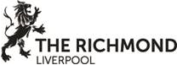
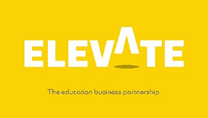

Name |  | Form

The Richmond Aparthotel, Liverpool. Virtual Work Experience
Task Four
https://my.matterport.com/show/?m=aishQ7duNMJ/
Design a flyer or poster for either social media or tourism websites

VisitLiverpool - Welcome to Liverpool

Your poster should be designed to attract visitors not only to the aparthotel but to the City of Liverpool. Include the top 10 sights in the city and a ‘things to do’ guide.

Thank you for completing this task on The Richmond Aparthotel, Liverpool

Copyright Elevate EBP

